**First session :**

* Devops comes into picture like Development + Operations. Development includes Testing Engineer, Releasing Manager, Build team and Security team.
* Development is nothing but Developers, they will create code in their personal laptop and they push into the Version control like ( GIT Hub, GIT Lab ). Once they create code, Devops Engineer takes the responsibility of delivering the code into Production.
* Basically, devops Engineer is going to the automation between Development and Operation.

**Before DEVOPS:**

We have SDLC, Agile and Devops in Waterfall method.

In SDLC, we need 3 teams for any application or product needs to be released or delivered into the production i.e Developer, Testing Engineer and Operation Engineer. They do not have any communication. TE and OE sits idle until Developer push the code. Developer sits idle while in testing, and until gets bugs or issues in operations. There is no Automation, lots of dependency b/w three teams.

In Agile, there is automation between Developer and Testing but still Operation has to be done manually.

In Devops, All the teams can work together, Automation is there in all the teams.

This automation can be done through the pipeline that we are going to build by using open sources tools.

**PIPELINES**: CD-CT-CI-CD-CM-CM

* Continuous develop
* Continuous testing
* Continuous integration
* Continuous delivery
* Configuration management
* Continuous monitoring

**PROCESS STARTS**

Developer should push the code from him personal system to the tool called VERSION CONTROL which is cloud because if his system failures, entire code will be crashed.

We have GIT Hub, Bit bucket and SVN. GIT Hub is used by the Microsoft.

Testing Team need to take the code from the Version control but here what happens Testing team manually should not take the code. We need automation here which is called Integration tool i.e Jenkins. Jenkins takes the code from the Version control and give it to Testing team then, Testing team will start analysing the bugs. Mostly, these two tools i.e Jenkins and Testing ( SIT, CIT, CAT ) install in Linux server.

So, Jenkins and Testing tools will be in your local Linux server and GIT version control will be in cloud.

17:30 stopped.

1. git config --global user.name "Your Name"
2. git config --global user.email [youremail@yourdomain.com](mailto:youremail@yourdomain.com)
3. git init [directory] – (initializing the git repository) create a Git repository from an existing directory
4. ls – what are the files in the working directory (untracked)
5. git status – what are the files in the staging area (tracking)
6. git ls-files – what are the files in the local repo (tracked)
7. git add – copy the file from directory to staging area
8. git commit -m “completed” – to commit the file and it will be in local repo( type however you want ‘ex – completed’)
9. git log –all details like who has created the file, how many times he committed, how many files he comitted, what are the changes he made
10. git show + commit id – all the commits will be shown
11. git log -- oneline – Recent action i.e recent committed one will be on top of the history
12. git tag -a “HTMLfile” +commit id m “adding tag for 1st commit” – to add tag( small ‘a’ means attribute and there should not be any space in attribute
13. git stash - do not allow to track the changes made(statements) in the existing file which is committed already(i.e stash will hide the new statements or changes of the committed file or existing file
14. git show - Outputs metadata and content changes of the specified commit
15. git stash list – shows the all stash ID
16. git show + stash id – shows which are all changes in stash
17. git stash pop + stash id – to revert back the stash id
18. git stash drop + stash id - The command deletes the specified stash( when you have stash conflict, stash will create a backup for lastest stash id, manually you have to drop the backup.
19. git ignore – .gitignore file tells Git which files to ignore when committing your project to the GitHub repository ( Ex: you created new file say “index.hmtl” and you dont want to track this new file “index.hmtl”. For that again you create a new file .gitignore and in that .gitignore, you put the file “index.hmtl” which you dont want to track.
20. git rm -- cached +file – To delete the file from the local repo but not from the working directory( if u don’t want the file which is already committed then you use this formula, if you don’t mention the “--cached” the file will be deleted permanently).
21. git branch – list all the branches in the repository
22. git checkout -b +branch name – to create a branch( when you are creating the branch, you should be in master otherwise new branch will take previous branch as master, so switch over the master and create a new branch)
23. git checkout master – to switch over the master
24. git merge +branch name – to merge the branch file in the master ( while merging the branch in the master also, you should be in master )
25. **Note:** once merging one file from one branch into master, we cannot merge the file with same file name from another branch into master coz merge id conflict will be there. So, we rename the second file name then the edited name file will merger into master under existing merge id automatically(manually we should not merge the renamed file coz master will take the renamed file and deleted the old file, we should not even the commit the renamed file we should go master and commit)
26. cat + folder name = This command displays says that “the file is created by whom”, it shows the statements of the file
27. mv filename1 filename2 – to change or replace the filename1 to filename2
28. git merge master – merging the master from the branch
29. git update master – to get update from the master
30. **7th session:**
31. In real time, to merge the branch file into the master, we need to raise the PR ticket. Reviewer review the PR ticket and merge the file into Master.
32. Master file should be in Remote repo only and Branch can be in local repo Remote repo
33. git remote add origin +github link – to put the master into the remote
34. git push -u origin +branchname - To push into the remote repository i.e Github (while you are pushing the branch to remote, you should be in branch )
35. **Note:** when you are using remote repo i.e from local repo to remote repo, we have four commands i.e…
36. git fetch origin +branchname – if something changes in remote repo (will give metadata from remote repo, we have to use this command in local repo)
37. git push – Pushing the file from local to remote (command should be used in local repo)
38. git clone – The git clone command is used to create a copy of a specific repository or branch from different project within a repository. Cloning the entire file or repo from remote (command should be used in local repo)
39. git pull origin +branchname – will pull modified files from remote repo (command should be used in local repo)
40. Pull request – Creating PR(Pull request ) ticket for merging the code from branch to Master( this will be done in Remote Repo)

Task : git rebase ( why we use this command, not much use in real time, for interviewer purpose )

**8th session:**

1. Jenkins – we have to configure the cluster [one master (Jenkins Master) and rest (Jenkins slaves) will be the slave nodes].
2. Jenkin Master only will have Dashboard 8080 and slaves will not have any Dashboard, slave will follow the Master.
3. First provisioning the Master (in aws). We need to launch the EC2 server i.e Linux virtual instance (virtual machine) for provisioning the Master.
4. Termius(Terminal) – download Termius (Remote Application) and Install - <https://termius.com/download/windows> [ Putty, SecureCRT, MobaXterm, ~/.ssh/config are Terminal tools ]
5. Create a New Host – Paste Public address of launched EC2 server in the Address box on right top – put some name in Label – Username & Password and then launch the Host.

For AWS Linux, ubuntu, Redhat –

Username: ec2-user

Password: downloaded key pair

1. The below Yellow shaded is private ip ( AWS recommended create and use Host name for private id ) that we can see in AWS under EC2 launched instance.

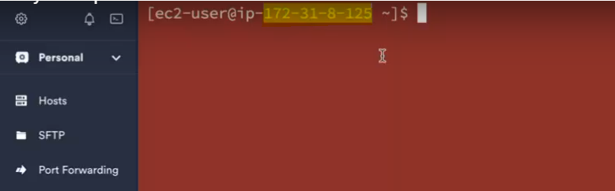

sudo lets you run commands in your own user account with root privileges. su lets you switch user so that you're actually logged in as root. sudo -s runs a shell with root privileges. sudo -i does this as well, but also acquires the root user's environment.

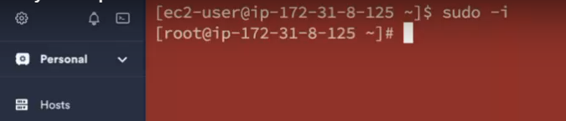

**Note:** IP address in binary code is taken default host name, we need to define the Host name. $ - it means normal user where as # - means root user.

1. How to define the Host name – command is “ vi /etc/hostname “. vi means vim editor. Then press i to make the status to “INSERT” mode and you can define the Host name.

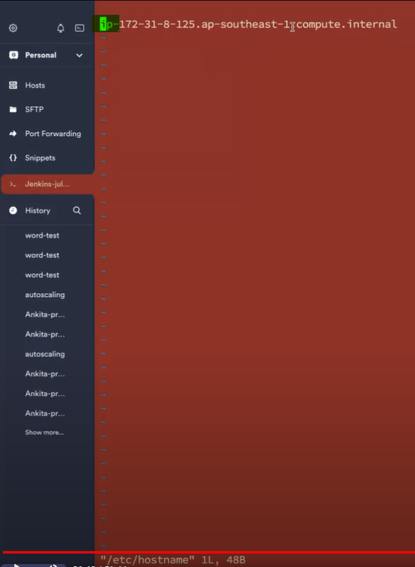

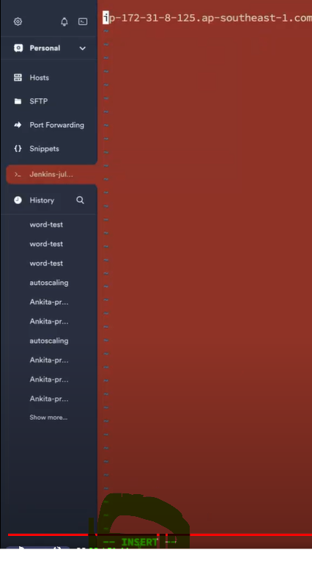

Once it becomes INSERT MODE, then type the Host name whichever you want.

How to save VIM editor: Press Esc + : + wq

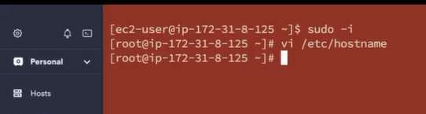

Host name still not yet changed, use command integer vaule “init 6” to restart the instance/server. In AWS console also, you can restart the instance by clicking the option “Rebot instance”

**Integer value:**

init 6 – restart

init 0 – terminate

init 1 – stop

1. How to install Jenkins for Linux - <https://www.jenkins.io/doc/book/installing/linux/>
2. First update the Subscription Management repositories in Tremius. Command is “yum update -y”.
3. Once Subscription management repositories is complete then install Java.

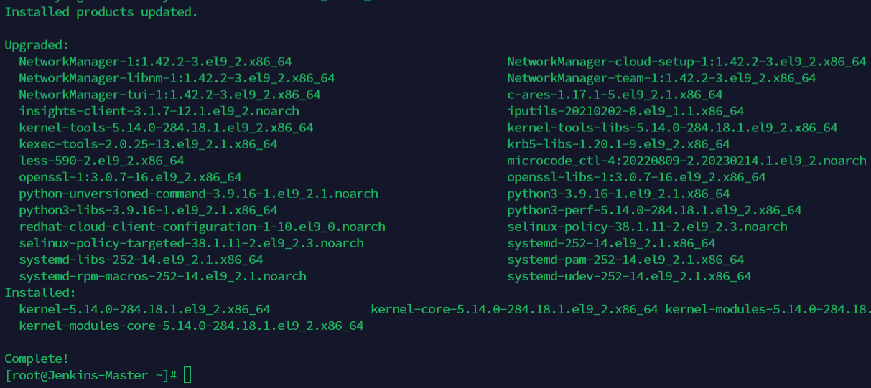

1. Copy and paste below command

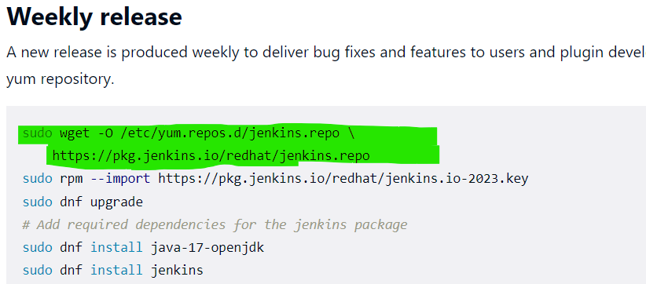

1. When you paste this command, if you get like below, then install wget also. Command is “yum install wget -y” and then paste above commands

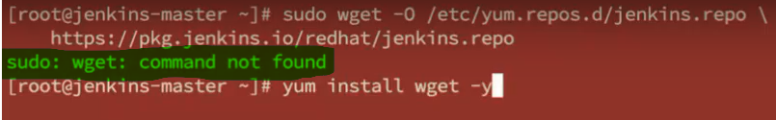

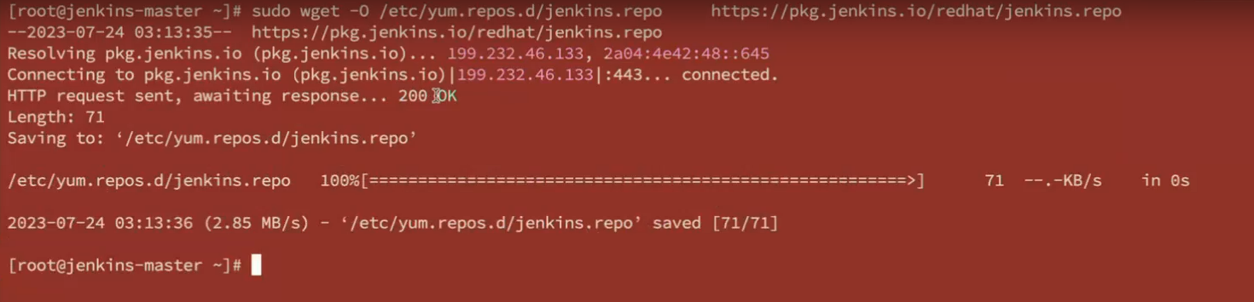

1. Once successfully completed, then paste the single single line command and enter.

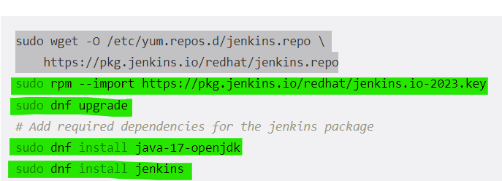

1. Lastly, Java will be installed successfully in below screenshot.

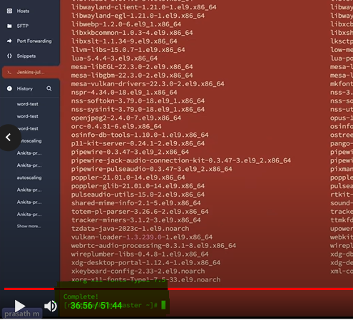

1. To see where is Java or Java path, command “whereis java”

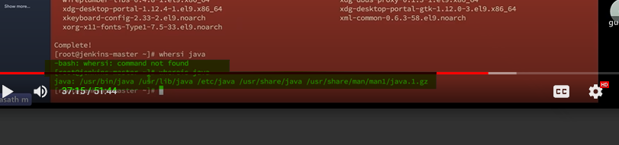

1. To see which java version, command “java --version”.

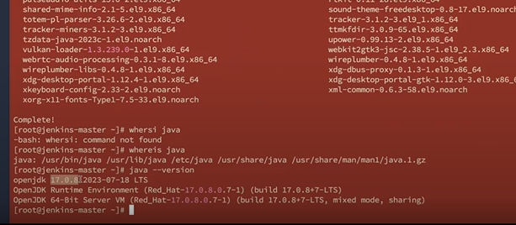

1. And Finally install Jenkins.

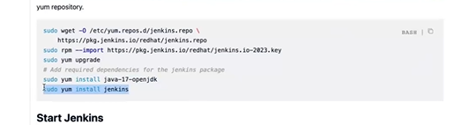

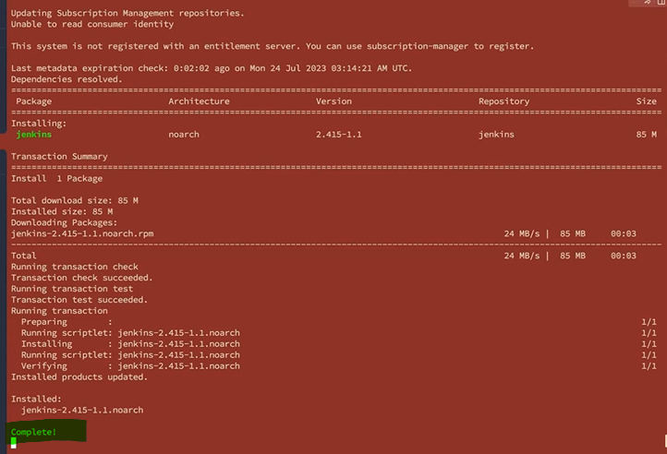

1. To see where is Jenkins or Jenkins path, command “whereis jenkins”
2. To see which Jenkins version, command “jenkins --version”.
3. Then you can start Jenkins enable using below commands

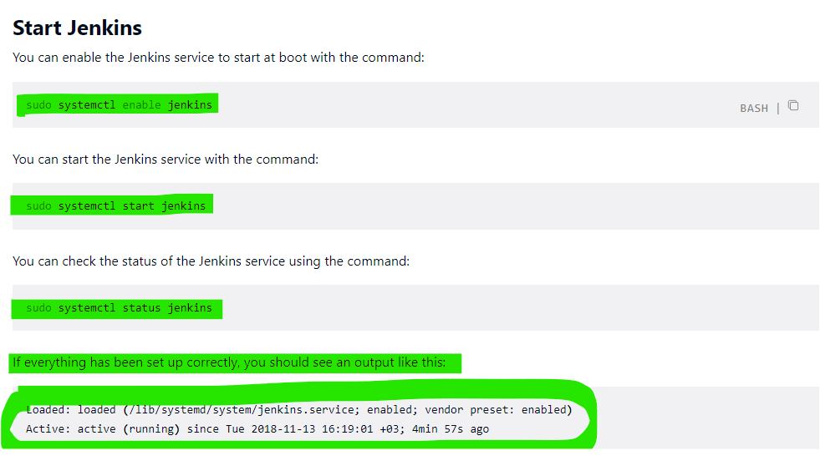

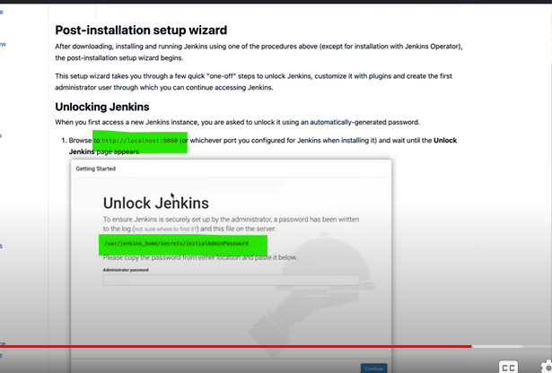

1. We need to open security firewall 8080 (see above screenshot ) in aws.
2. 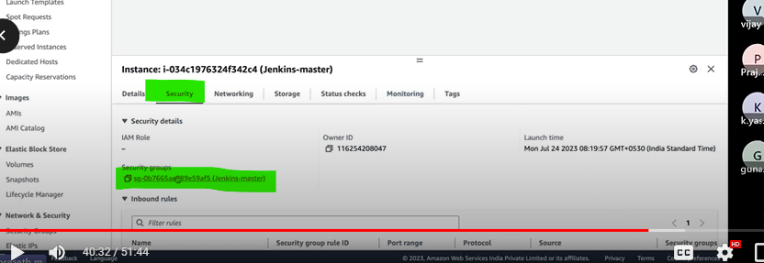

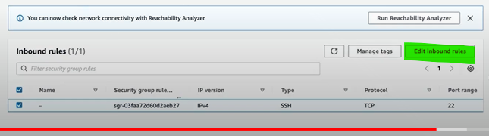

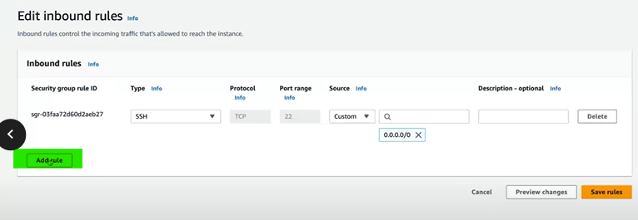

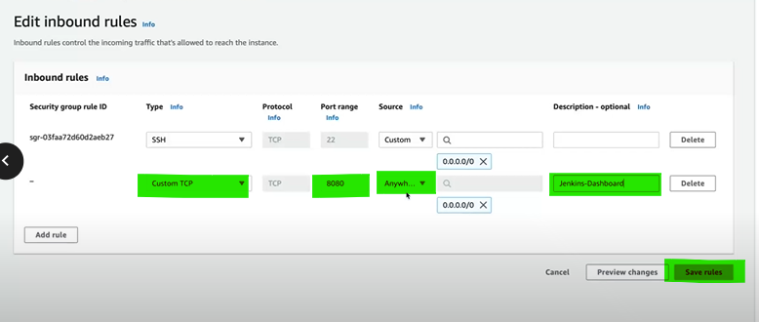

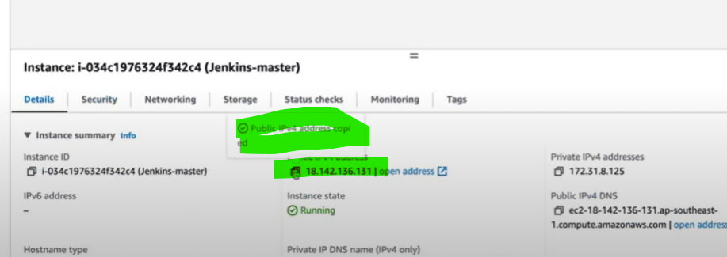

Paste the public address with port 8080 and enter, you will get Jenkins dashboard like below.

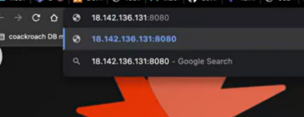

Jenkins dashboard, paste the link which is initial password in termius (command – cat +link), later you can reset the password

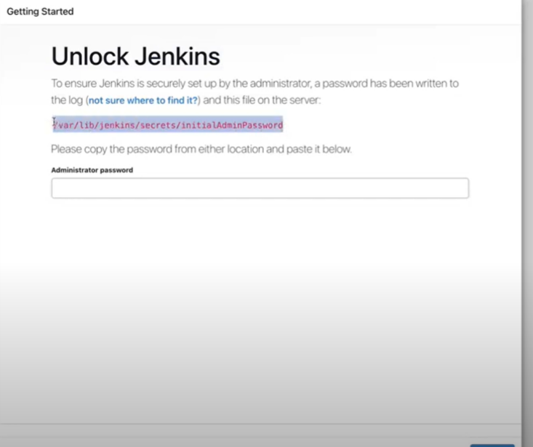

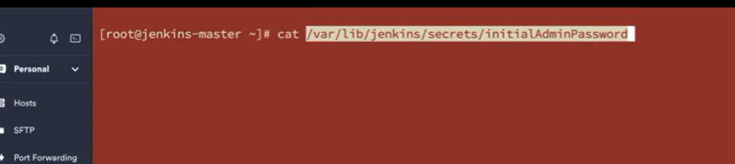

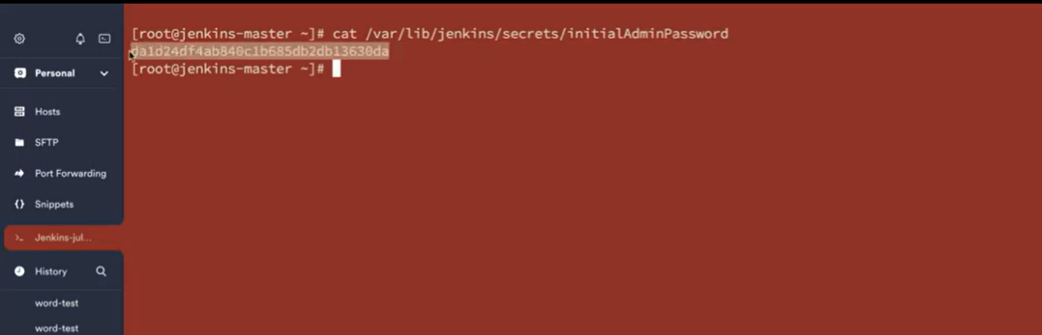

Copy above screenshot command and paste it in the administrator password box like below and continue.

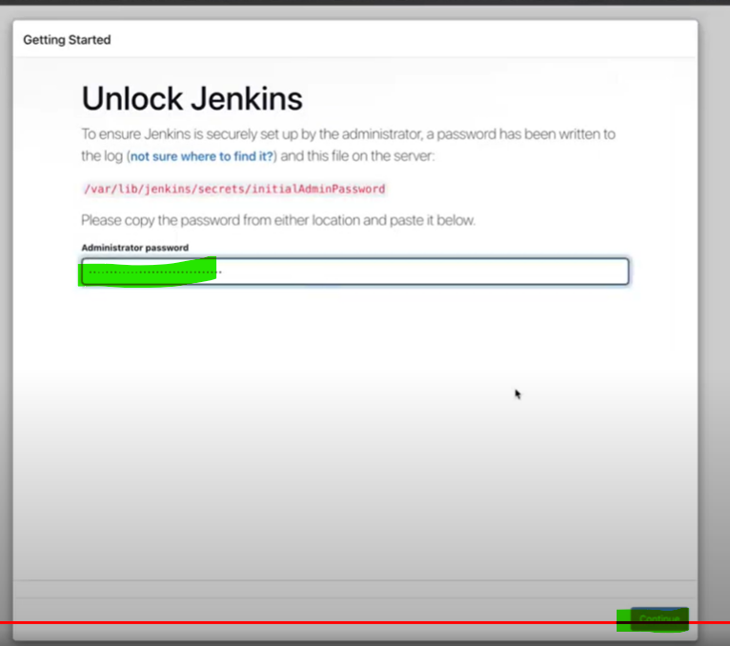

Then you will get like below. Finally, Jenkins has been installed.

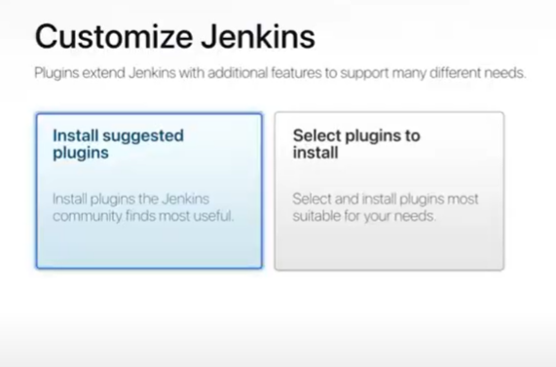

Jenkins is just a platform, if we need to perform in Jenkins, we need plugins which are developed by groovy language. Plugins are used to help Jenkins to communicate with some applications like “Github”.

Groovy language will be developed by developer not by Devops engineer.

In Jenkins, we have both Default plugins and also Customized plugins also available.

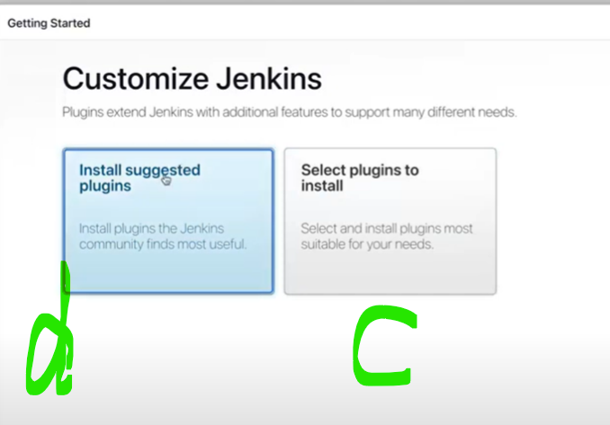

Install the default plugins like below.

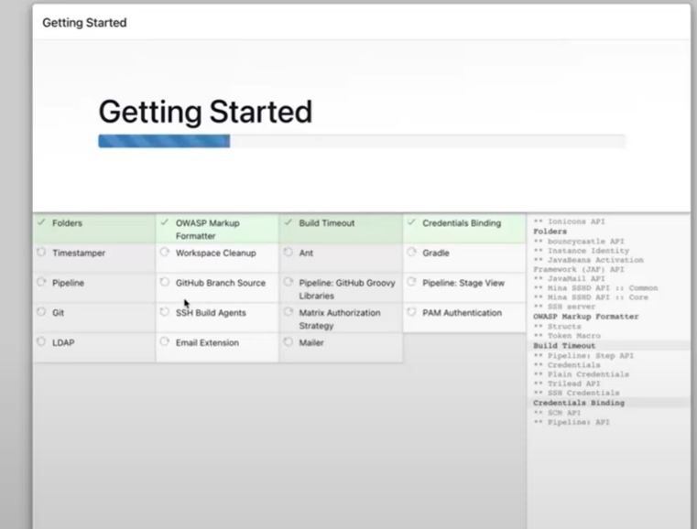 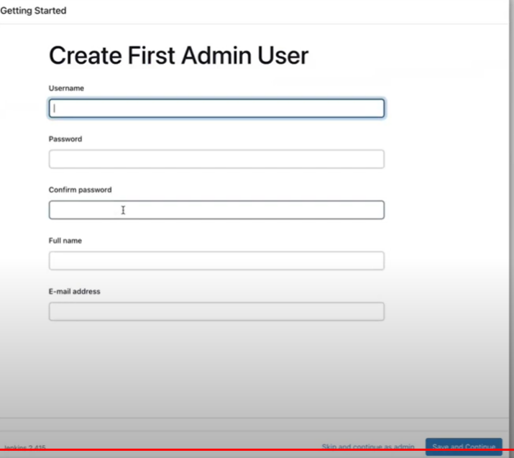

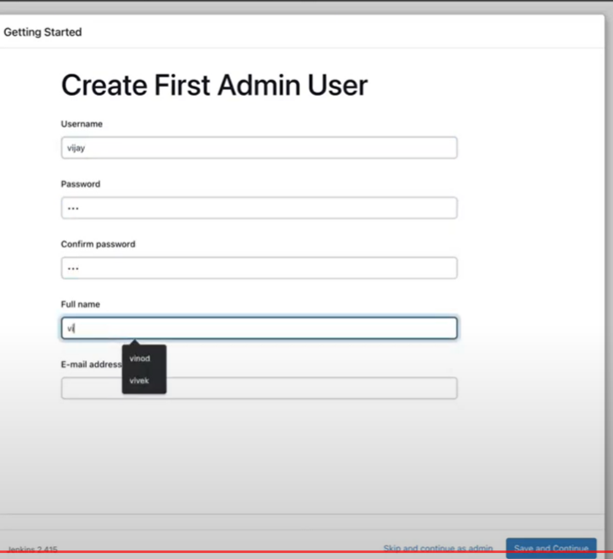 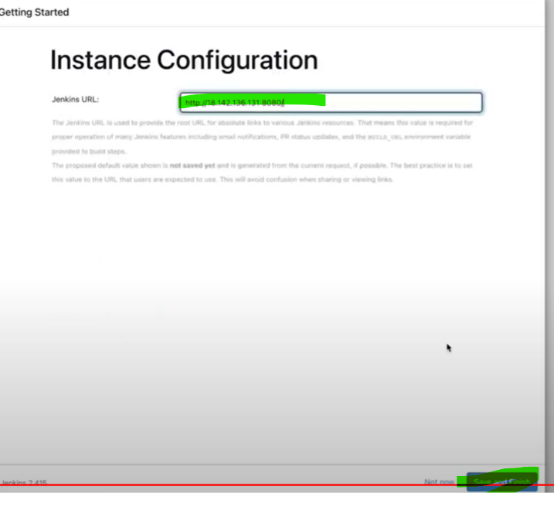

Jenkins Master is ready.

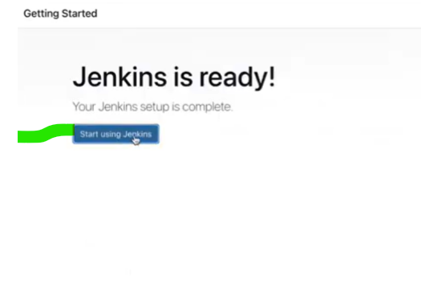

Jenkins dashboard.

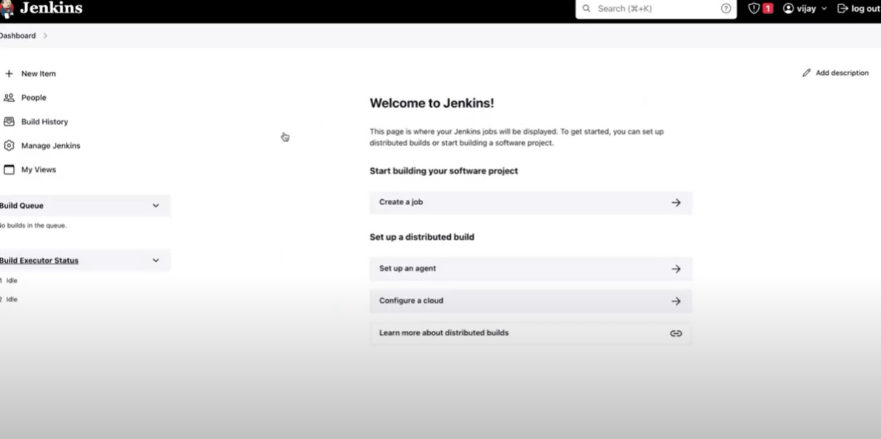

For customized plugins, follow below steps.

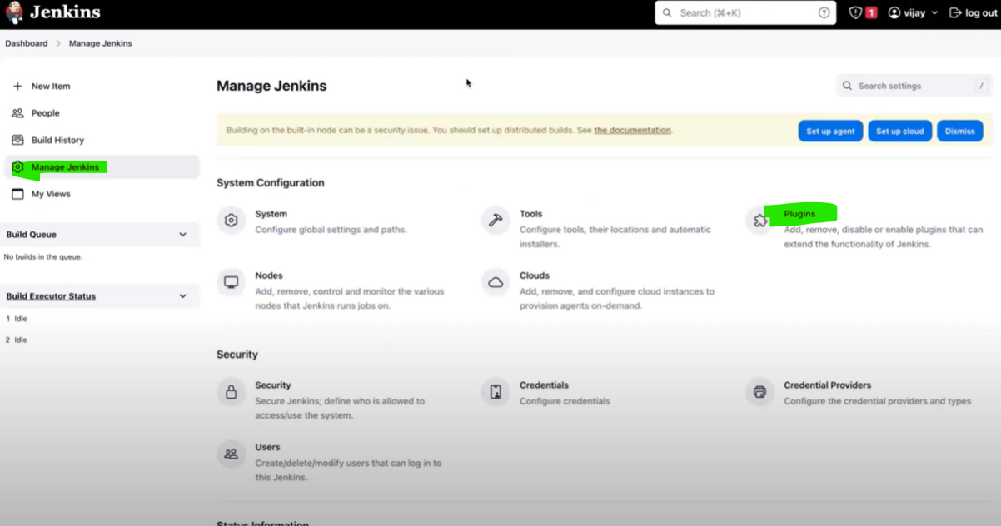 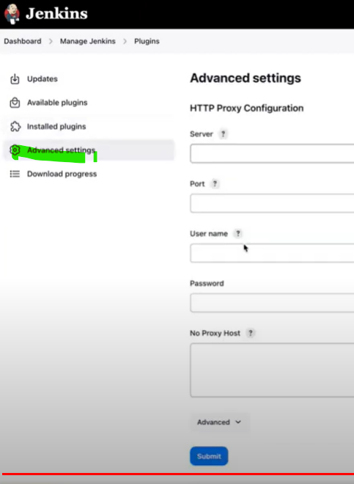

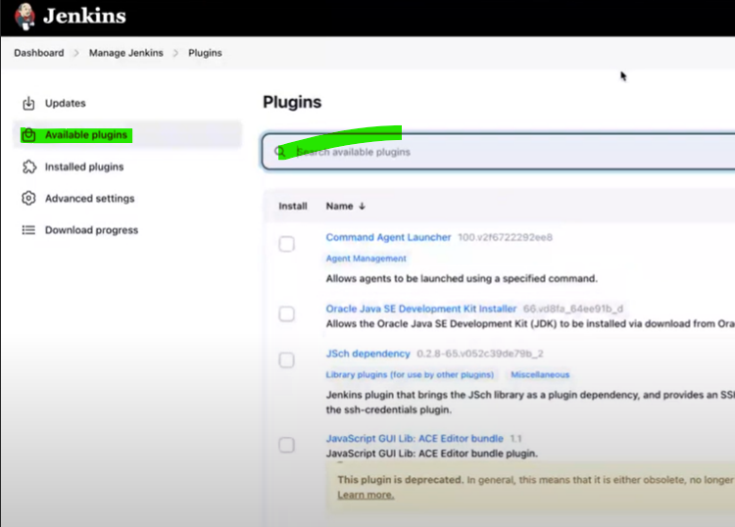

**9th session:**

1. We learn what is each icon in Jenkins. What we do in Jenkins Dash board is Front end (Implementation like Build, Release, ci-cd, pipelines) and what we do in Termius is Backend (to capture the logs, to troubleshoot point of view).
2. We create Jobs. Process will be like JOBS—GOALS (with Build Tools)—Plugins—Output (weather report). Based on weather report, application will be released.

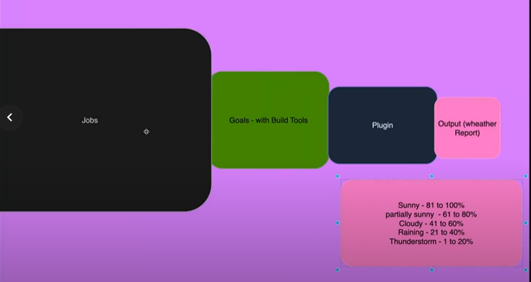

1. In Jenkins, we can create jobs in two ways. Like a) manually you can create or b) using Jenkins file(<https://www.jenkins.io/doc/book/pipeline/jenkinsfile/>). These Jenkins files will be created by Developer not Devops engineer.
2. Jenkins files are two types. A) Jenkinsfiles -CI B) Dinghy file.

Jenkins file – CI is Automation for Continuous Integration whereas Dinghy file is Automation for Continuous delivery/Continuous deployment.

1. Jenkins usage:

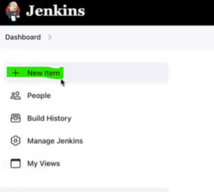 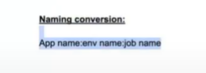

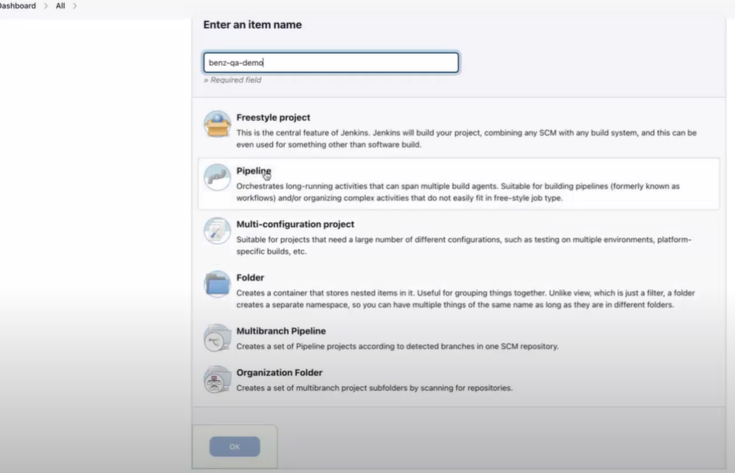

Freestyle project – we don’t use much in real time.

Pipeline – We use in real time.

Multi-configuration project – like this is Backend, this is Front end, this is middleware.

Folder – its just folder we create and keep it your workspace, your code.

Majorly we consume Pipeline.

1. Jenkins Dash board. (created new item with Freestyle)

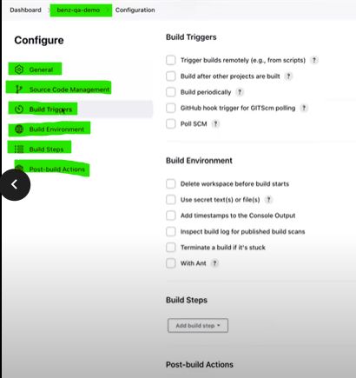

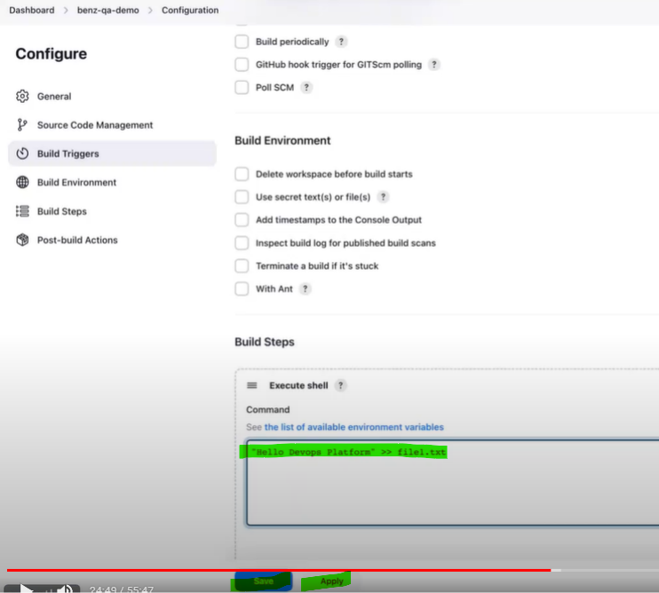

>> - In linux, >> means how many times you add the data, the number of times will be added and it will not be replacing the previous one. > - It will be replacing the previous one.

If any Jobs if you get an output and build, Jenkins will create a workspace.

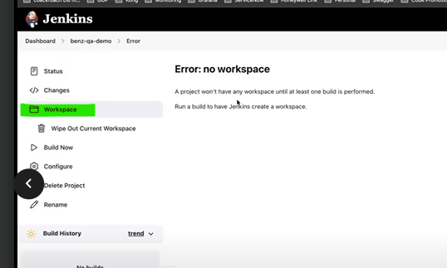

If you want to see the workspace in the backend, the command is “cd /var/lib/Jenkins” and “ls”

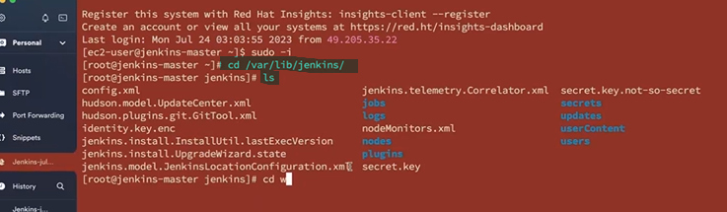

We need to build to see the workspace in backend. Command is “cd workspace”

1. Build.

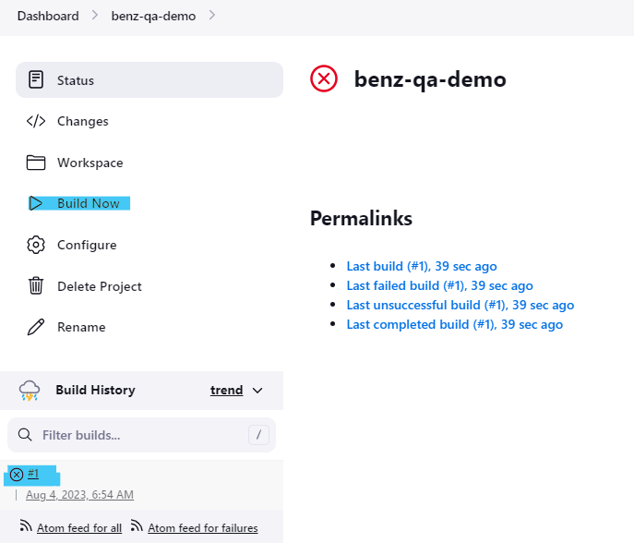

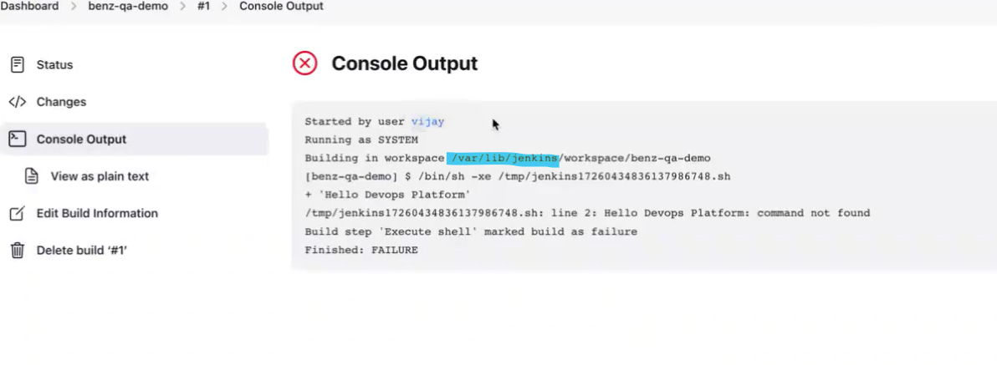

**Before build.**

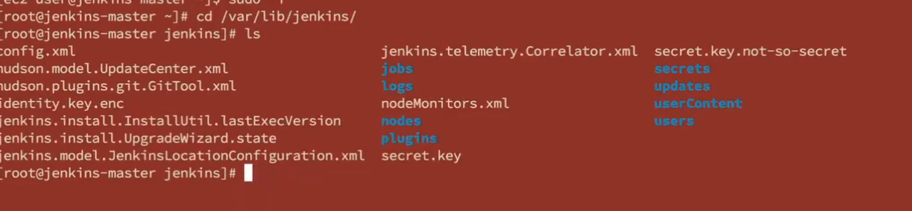

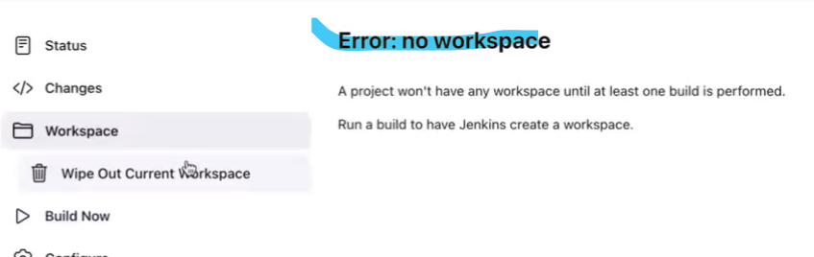

**After build.**

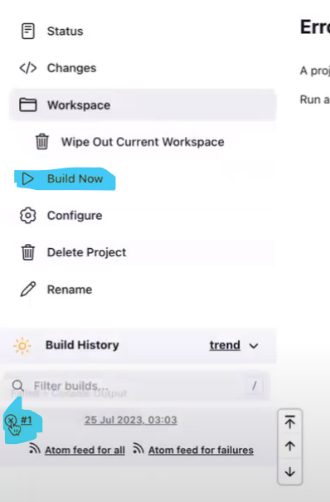

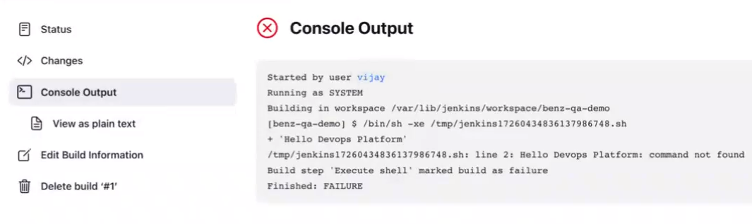

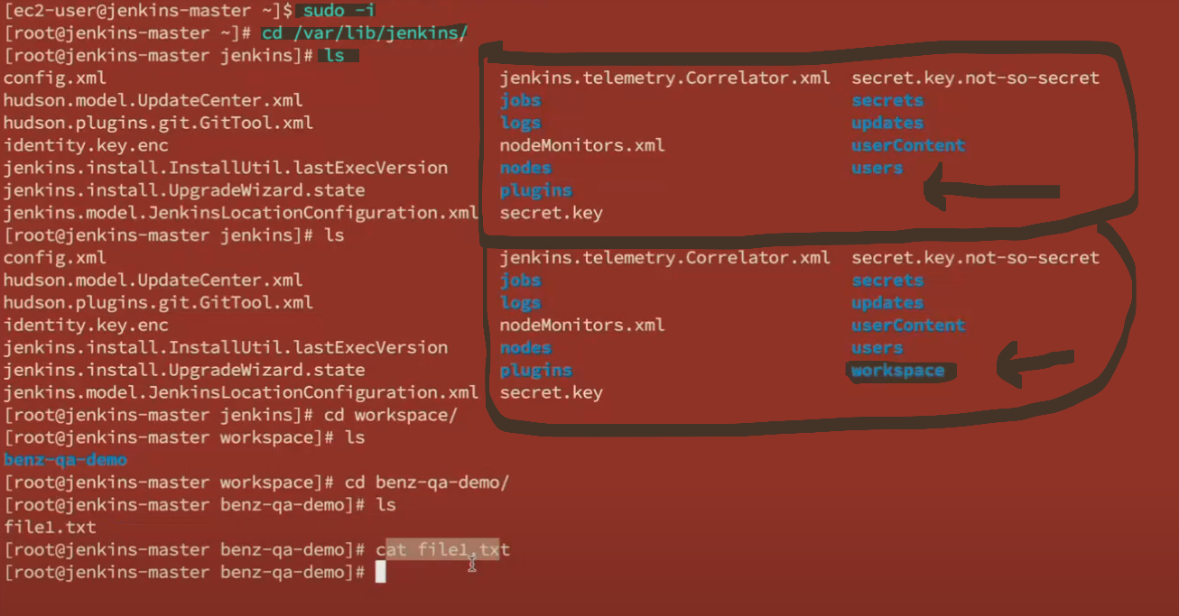

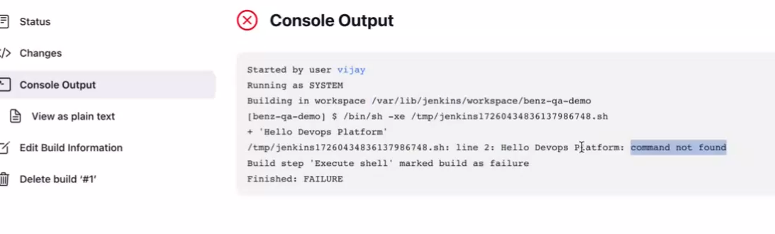

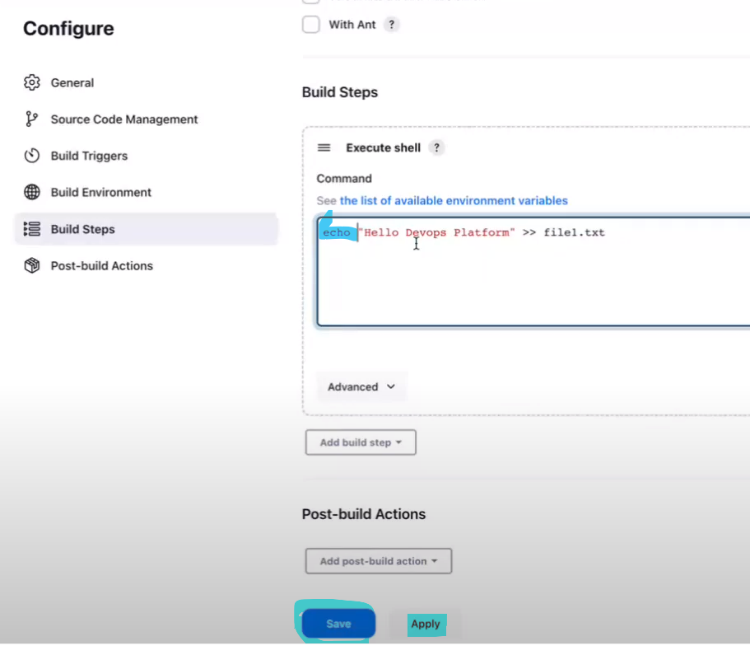

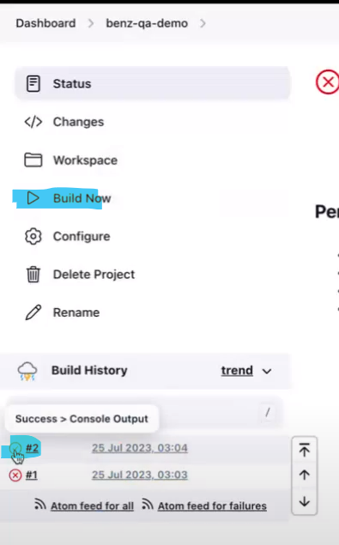

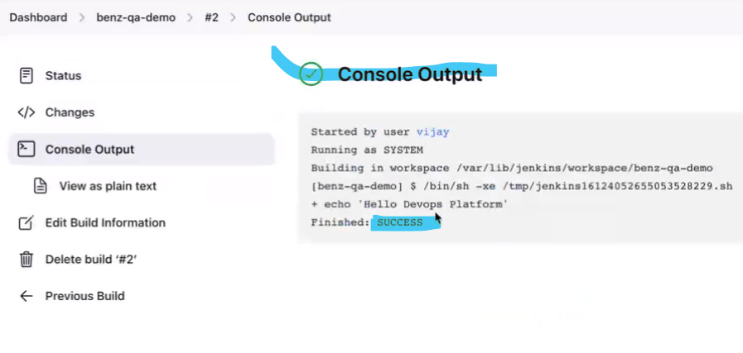

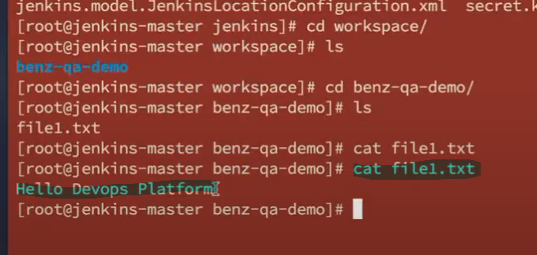

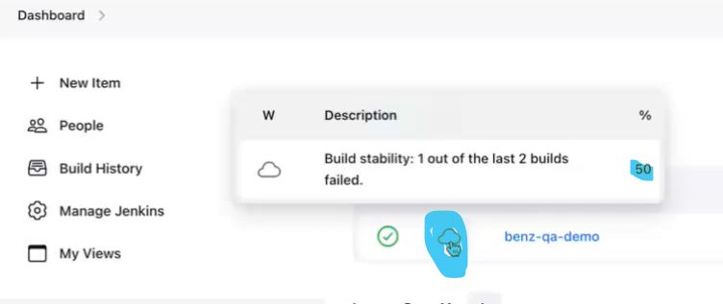

**To build again.**

If you build again and again, weather will be increasing from cloudy to sunny finally like 50%, 60%, 70% -----100%

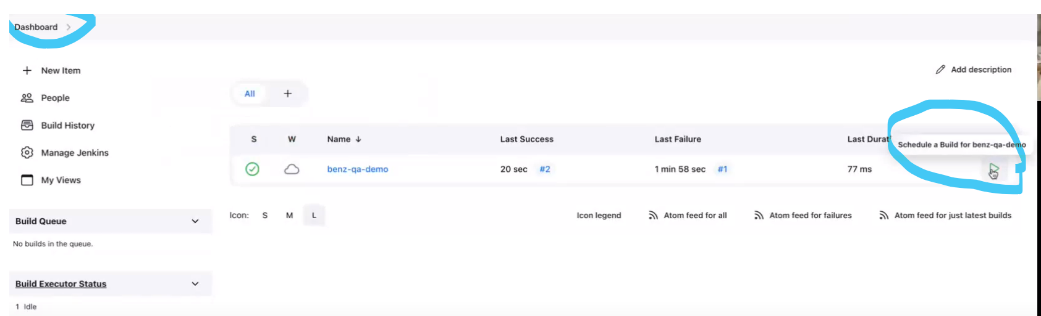

**10th session:**

1. To keep all the logs in Jenkins, we use the “Kibana”(licensed version) application which is used as Dashboard. Alternatively, Jenkins also send notification us by working as Audit trail.
2. If any jobs fail, we use Kibana and Jenkins Audit trail for keeping the logs and send us the notifications.
3. USER POLICIES:
4. Matrix strategy.
5. Project – Matrix strategy.
6. How can we onboard the user into the Jenkins server? It is in two ways.

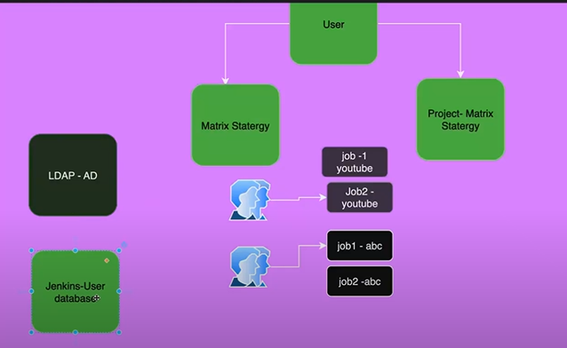

In real time, LDAP (Lightweight directory access protocol)is used to onboard the user. Once the user is onboarded, they will integrate the user into the Jenkins server.

LDAP provides a means to manage user and group membership stored in Active Directory. LDAP is a protocol to authenticate and authorize granular access to IT resources, while Active Directory is a database of user and group information.

In another way, Jenkins – user database will be created on Jenkins server but many companies prefer the LDAP in real-time.

**MATRIX STRATEGY: (Giving centralised or common privileges to single user for multiple projects/jobs)**

A matrix strategy lets you use variables in a single job definition to automatically create multiple job runs that are based on the combinations of the variables. For example, you can use a matrix strategy to test your code in multiple versions of a language or on multiple operating systems.

**PROJECT - MATRIX STRATEGY:**

IF you want to give a customised privilege or particular project to user, it is called Project – Matrix strategy.

1. If you want to create users.

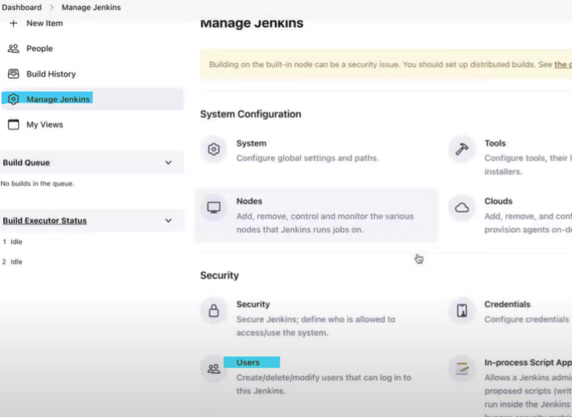 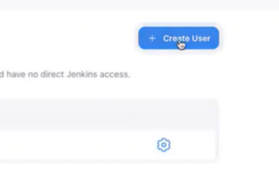

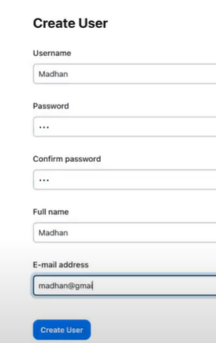 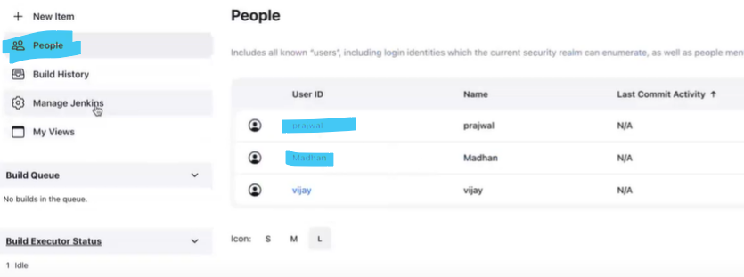

If you want to privilege

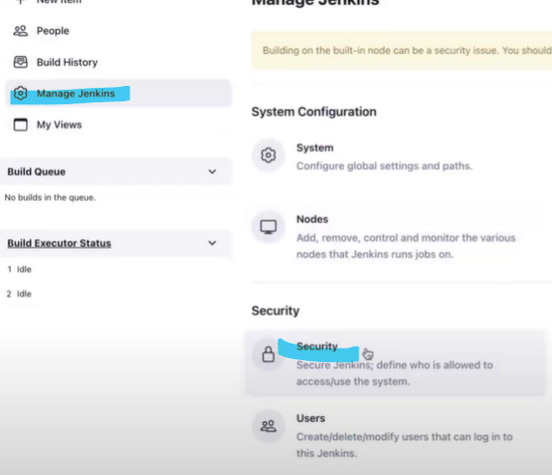

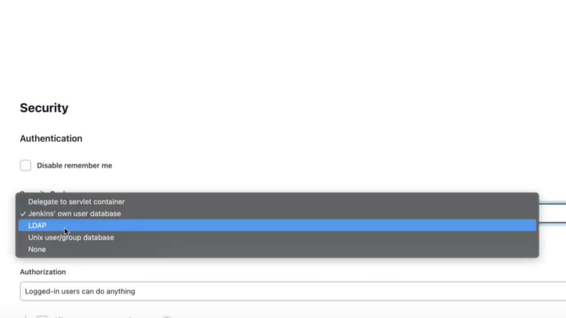

1. Right now, using the Jenkins own user database.

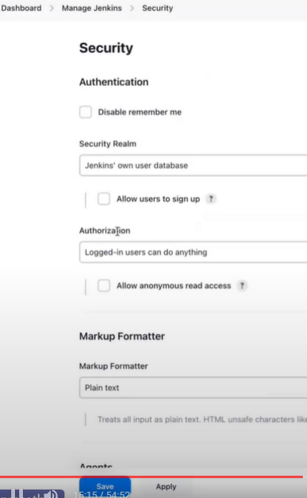 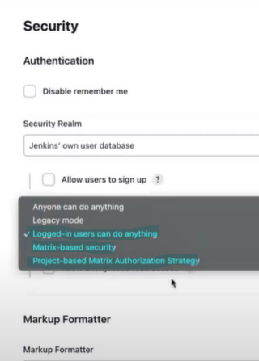

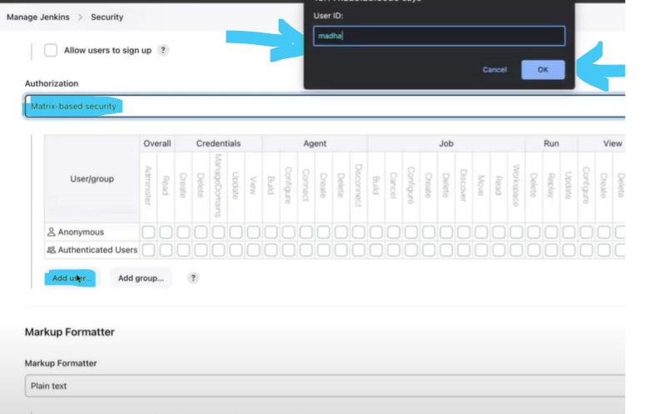

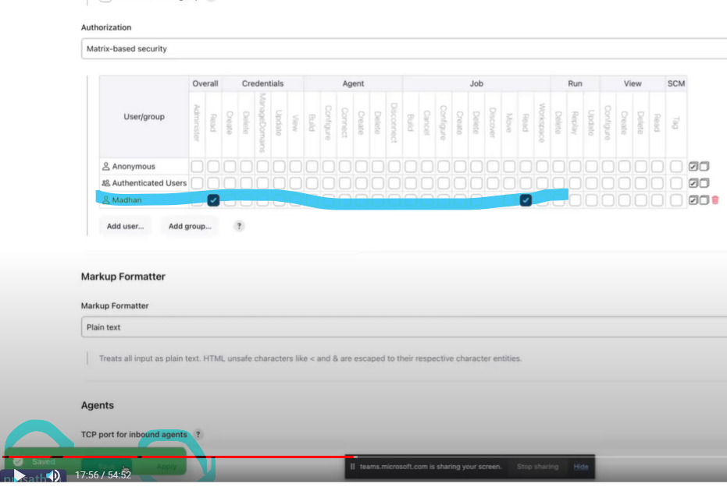

New user can use the below link for login with his credentials but he cannot build the content.

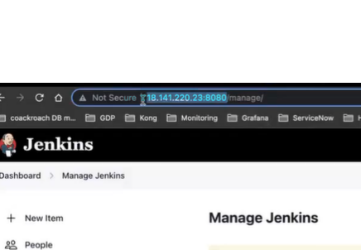 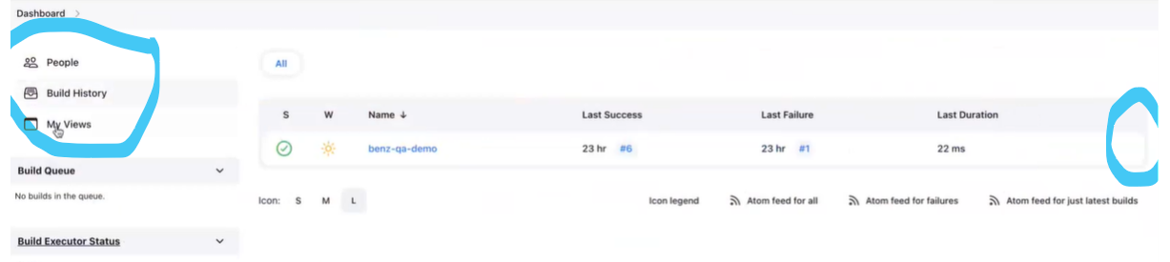

If any new job we create with admin credentials in the Jenkins, created user who is given the centralised privileges can also see in his account.

Created new job in admin account.

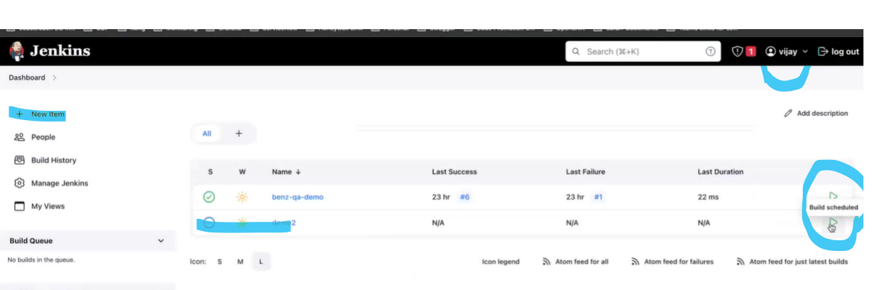

Created user also can see in their account.

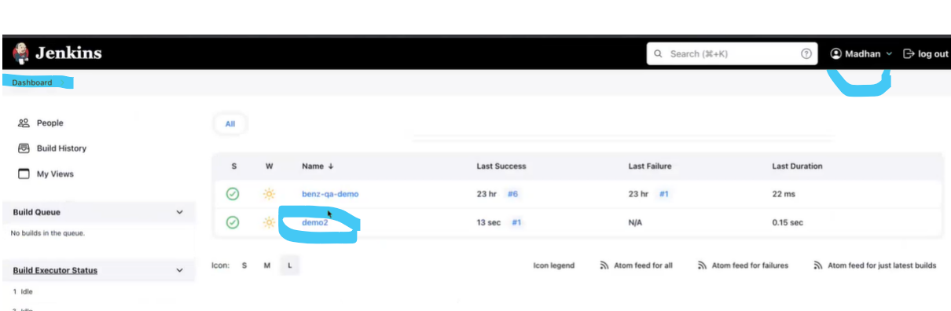

**PROJECT - MATRIX STRATEGY:**

Here, created user can see only the privilege which is given to him, he cannot see the all other jobs in his credentials. See below example how it is given only customised privilege.

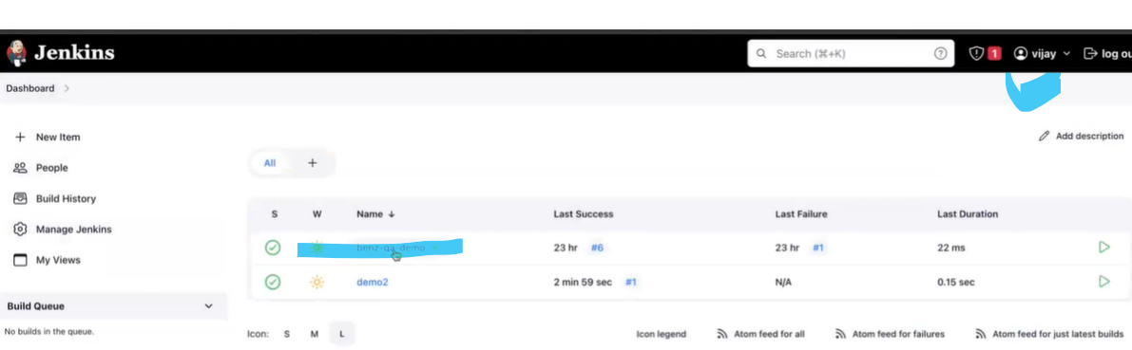

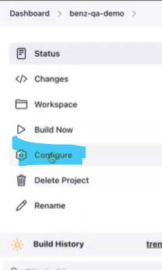 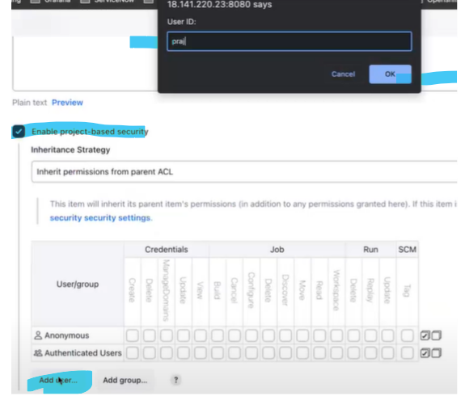

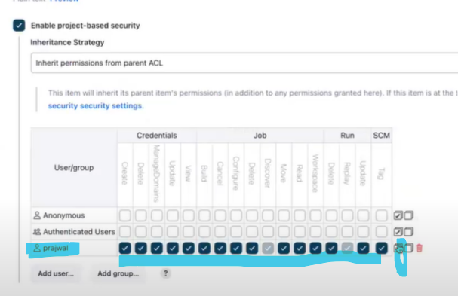

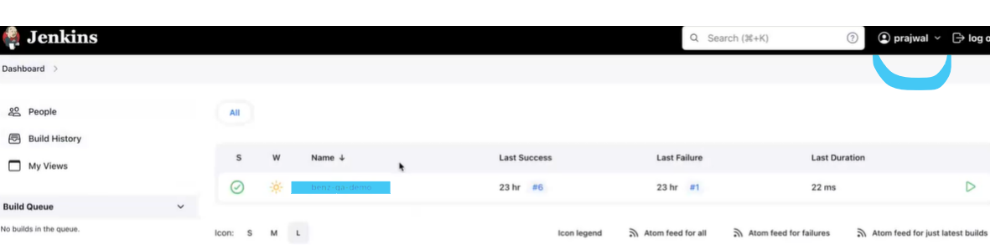

1. Configuring Master and slaves.

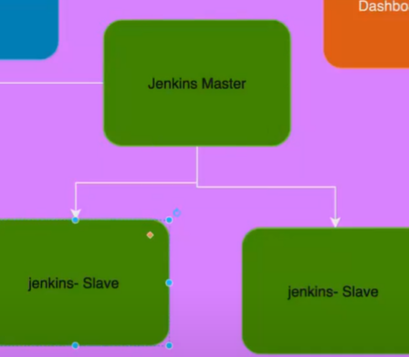

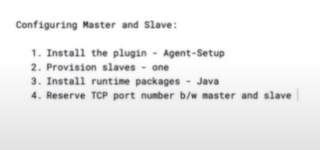

1. **Install the plugin – agent setup.**

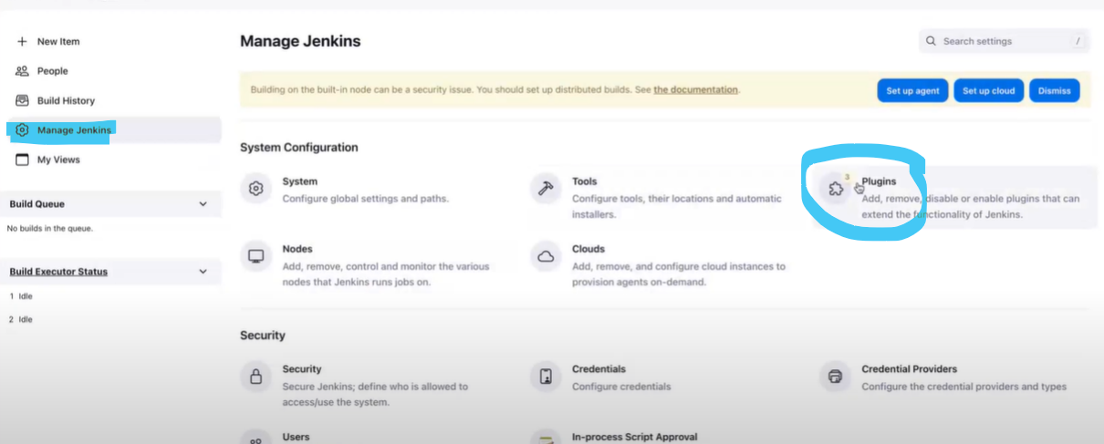

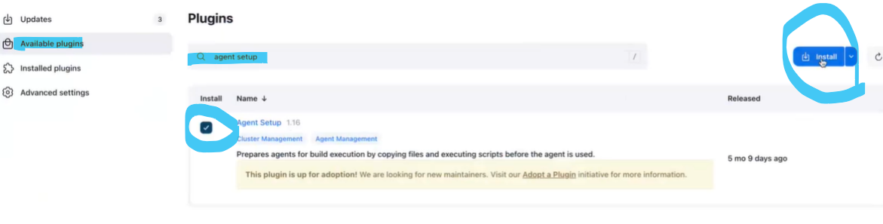

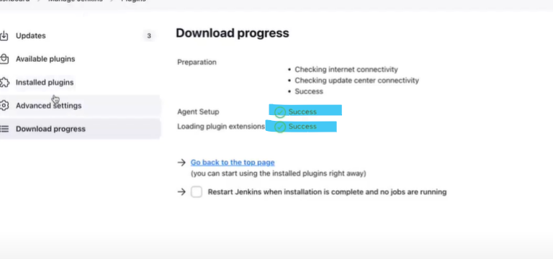

1. **Provision slaves – one ( in AWS )**

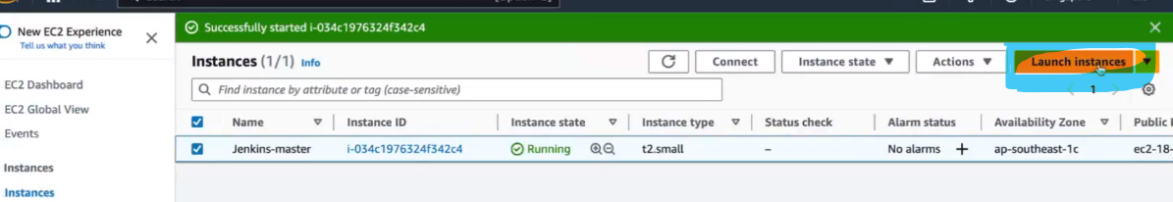

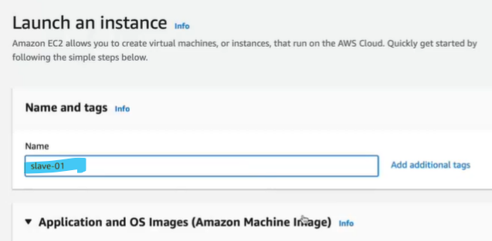

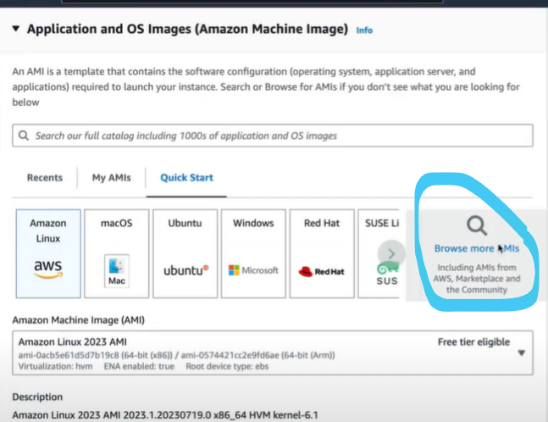

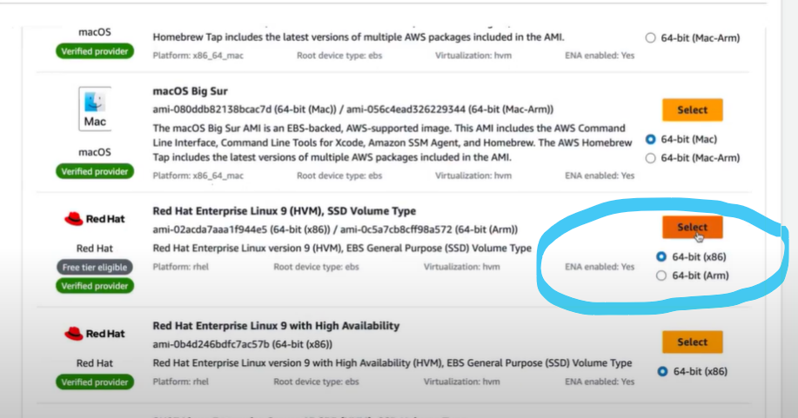

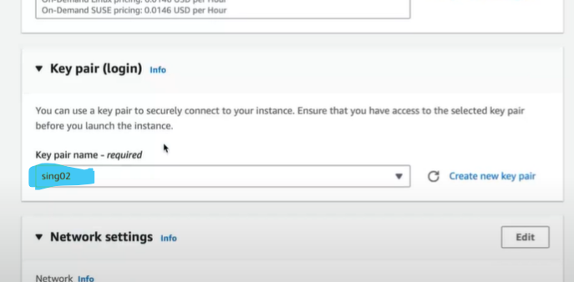

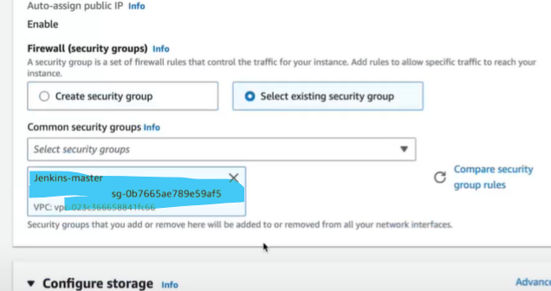

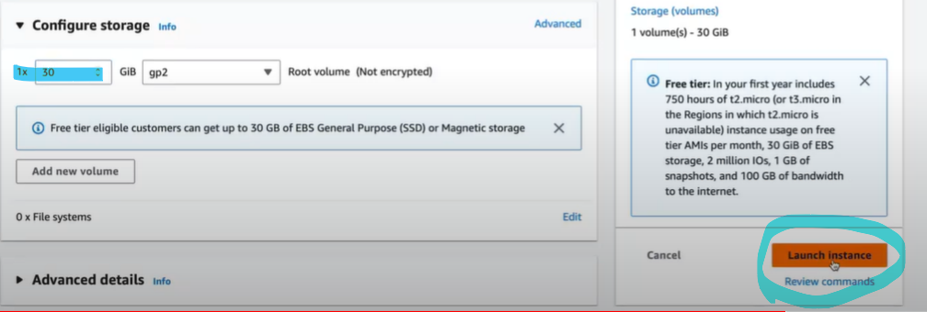

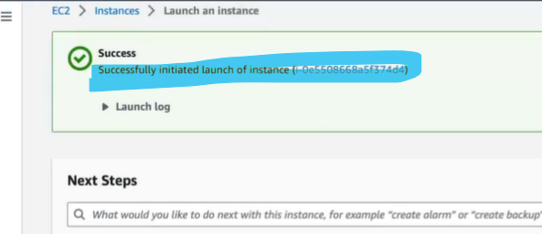

Java application to build on Slave 1 and .NET application to build on Slave 2.

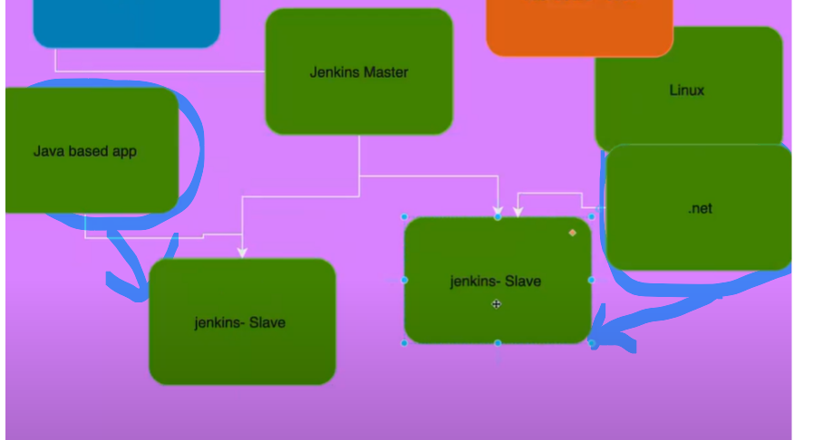

Note: Don’t install any Jenkins package in Slave, if you install in slave, then it will take it as Master.

To log the Slave Host or to run the Slave Host in the Tremius.

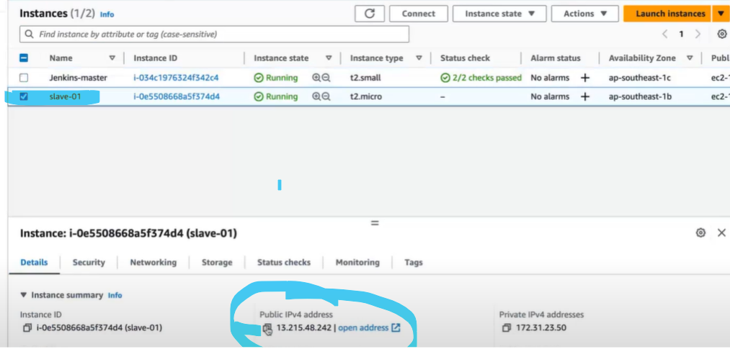

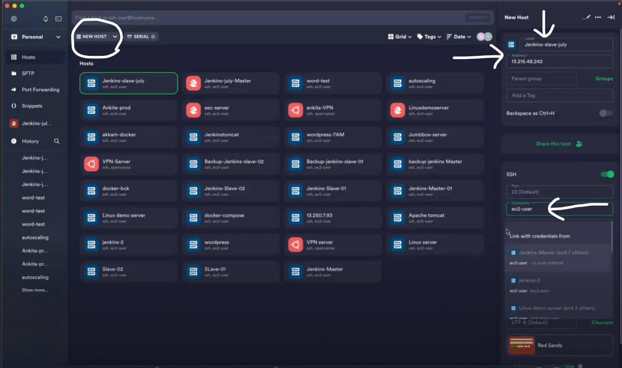

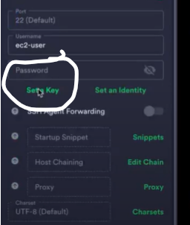 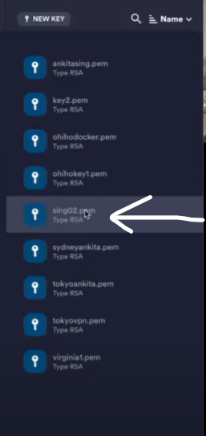

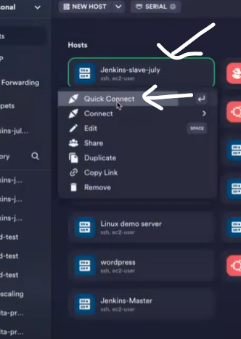 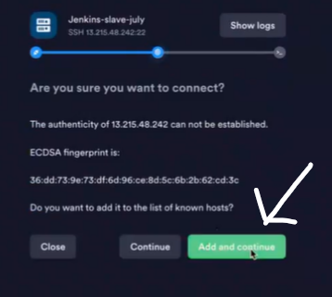

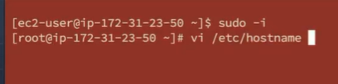

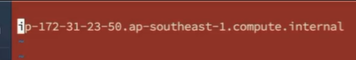

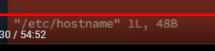

Type “i”



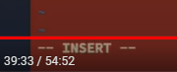

To give name for Slave, give any name you want

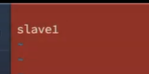

To save the slave host name ( click ESC+:+wq and Enter )

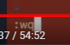

To restart

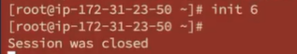

To update the server, the command is “ yum update -y “

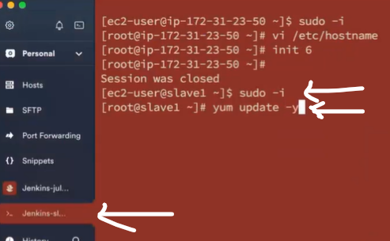

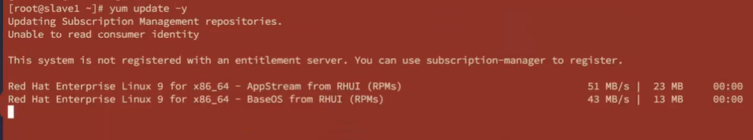

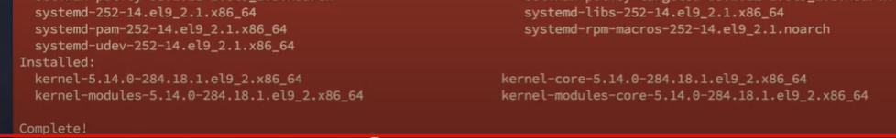

Note: Don’t install any Jenkins package in Slave, if you install in slave, then it will take it as Master. Java is must for Master not for slave, for slave if you .NET you can install .NET.

1. **Install runtime packages – Java**

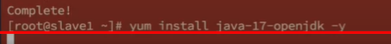

1. **Reserve TCP port number b/w Master and Slave**